# The Best Wordpress SEO plugins

## Search Engines-

What is the foremost thing you do when you get stuck in a query? You do your research on search engines. Search engines have become the most sustainable part of our working life as well as our personal life. To search about any topic, to know the medications of a disease or to do any delivery searching. Google has answers to every question we ask it. There are many search engines available on the internet like google, bing, yahoo etc. They are web based tools which can solve any query of ours and locate information.

## Search Engine Optimization-

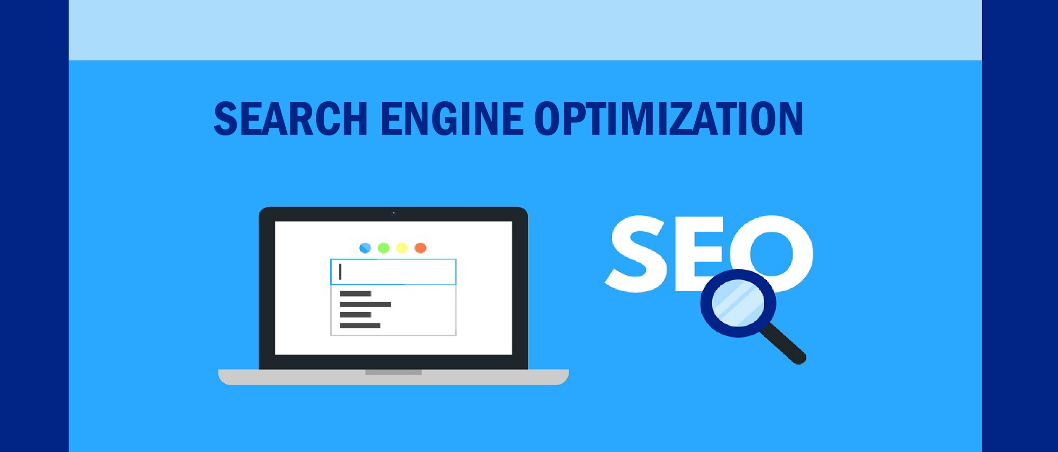

Search engine optimization is a procedure which helps to improve the site and grow business. This improvement will increase visibility of searches and garner attention and prospects and attract existing customers to your business. Search engines with the help of bots crawl pages on the web and visit all sites and then collect all the information and put them in index. Then analysis of pages is done and then they are ranked according to the factors and then determine the order of pages that will appear in the search results.

## SEO Plugins-

Seo plugins help the webpages to reach more people by allowing web masters to easily optimize website’s code to make it more crawlable by search engines results. The page title and meta description are very necessary as they appear in the code of your page and tell the search engine what page is about. So, SEO plugins allow you to easily add meta description to your page.

Wordpress is mostly known for being SEO friendly “out of the box.” There are thousands of WordPress SEO plugins from which you can choose from. In order to reach the next level some additions to your blog may be the only thing that you might need. WordPress SEO plugins are the other thing beside WordPress SEO by Toast to XML sitemap, which can help you reach that level. We will now discuss some of the plugins that can help turn your site into an SEO powerhouse. Search engine rankings may not be guaranteed by these plugins but they will definitely improve the chances of SEO success and help you get a better site.

## Some Of The Plugins Are:

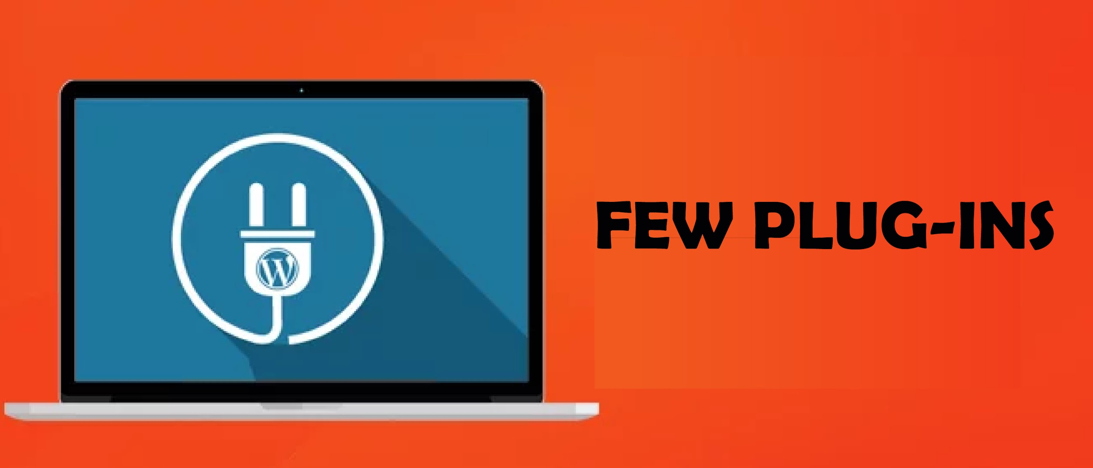

### Yoast SEO:

Yoast SEO is one the most preferred and favorite plugin out there. And it is also the most popular SEO plugin on WordPress and there is a reason for that. It has an overall rating of 4 out of 5 stars with approximately 2000 reviews. For improving Wordpress SEO,either by creating better content or by optimizing your site or both, this plugin may be the best place to start. The features include :

* Page analysis tool.
* Technical WordPress SEO
* XML Sitemaps functionality

### All In One SEO pack:

All in one SEO Pack is a plugin that is worthwhile and and you can try it for sure without getting worried about the results. It’s name is kind of self explanatory. It was released in 2007 and this plugin has been providing webmasters with an easy way to use solutions to many [**SEO company**](https://technosoftwares.com.my/search-engine-optimization/) related challenges. The biggest advantage of using All in One SEO Pack is that you do not need to have any experience to get started, hence it is one the best plugins for beginners.

### Google XML Sitemaps:



The search engine out there for sure finds your content without being pointed in the right direction, but you will have to sit back and hope for the best. This problem is solved by Google XML Sitemap. Google XML Sitemaps plugin will help you generate a sitemap automatically. Hence making it easier for search engines to index your blog. What is best is that once you have created a sitemap and you are comfortable with its settings, you would never have to do anything else. The plugin does everything else for you like updating your sitemap after each new piece of content that you are going to publish in the future.

### Broken Link Checker:

Keeping up with the management of the blog is a problem that most of the people face as they create more and more content. To solve these problems tools such as Broken Link Checker come into the view. This plugin helps you in checking your content for the broken links and missing images. However if you are very lucky and smart you will never be notified that there is something wrong with your site, but of course chances of this happening are very low.

### Google Analytics By MonsterInsights:



Google Analytics by MonsterInsights plugin tracks website visitors, top keywords and other similar types of data. Beside this, it have have approximately 11 million downloads, but what's more interesting is it’s feature list:

* **Simple Installation using Google Analytics API**
* **Ability to use the asynchronous tracking code**
* **Include both link tracking, outbound and internal**
* **Have access to both demographics and interest reports**

The main benefit of this plugin is the ability to review your Analytics from your WordPress dashboard so that you do not have to jump back and forth between your website and Google Analytics.

### W3 Total Cache:

### 

Most of the people do not think about the speed of your website and can understand this can impact their search engine rating. It is very important to provide a lightning quick experience. After the last ranking, it is very clear that speed is a ranking factor and it isn’t something that can be overlooked. W3 Total Cache plugin is used to solve this problem. With this plugin you can improve the site speed as well as the experience of the user.

### Wptouch Mobile Plugin:

A WordPress website needs to be mobile friendly these days as many people use mobile phones to view the websites. The lack of a website that is mobile friendly can affect your ranking in a negative way. This plugin is very useful, especially when you do not have the time or money or resources to pay a developer or to upgrade the site on your own. This plugin is so easy to use that it simply adds the most elegant mobile themes for mobile visitors of your site.

## Conclusion:

So if you are really very serious and adjudicate about growing your business then you should be intrigued about it and use every tool wisely. Search engine companies bestow many advantages which will help you to get more conversions and sales from the web. Investing time and money on [**SEO marketing services**](https://technosoftwares.com.my/search-engine-optimization/) will give you a high return of interest. Seo plugins are the best tool of search engines that will make your profit high and will get you more clicks and customers.

**Meta Description**

Best SEO Plugins for WordPress (Tried & Tested) · Run a search for “SEO” in the WordPress plugins directory. Yoast SEO reigns supreme as the king WordPress SEO plugin and is what we use here on the Kinsta blog.

**Keywords**

seo company

seo marketing services

**Author’s Bio**

**Name:** Rohit Yadav

**Designation:** SEO Executive

**Social Media**: [Facebook](http://www.facebook.com/rohityadav4181) & [Instagram](https://www.instagram.com/rohityadav_4181/) & [Linkedin](https://twitter.com/rohityadav4181) & [Twitter](https://twitter.com/rohityadav4181)



Myself Rohit Yadav and I serve as an Seo executive at a leading company named Techno Softwares. Also, technosoftwares is one of the[**seo company in Malaysia**](https://technosoftwares.com.my/search-engine-optimization/) which performs SEO .